9.1.2.1 Classification of Manufacturing Processes

Most widely used manufacturing methods for laminated fibre composites are as follows:

9.1.2.1.1 Open Mold Process

- Spray lay-up - Chopped roving and resin sprayed simultaneously, rolled.

- Hand lay-up - Lay-up of fibres or woven cloth, impregnate, no heat or pressure.
- Filament winding.
- Sheet molding compound.
- Expansion tool molding.
- Contact molding.

9.1.2.1.2 Closed Mold Process

- Compression molding – Load with raw material, press into shape.

- Vacuum bag, pressure bag, autoclave - Prepreg laid up, bagged, cured.
- Injection molding – Mold injected under pressure.
- Resin Transfer – Fibres in place, resin injected at low temperature.

9.1.2.1.3 Continuous Process

- Pultrusion.

- Braiding.

All the methods described above are discussed in detail in the following paras.

9.1.2.1.1 Open Mold Processes

Open molding offers a number of process and product advantage over other high volume and complex application methods. These include:.

- Freedom of design

- Easy to change design
- Low mold and/or tooling cost

- Tailored properties possible

- High strength large parts possible
- On-site production possible

Disadvantages associated with the open molding process include:

- Low to medium number of parts

- Long cycle times per molding
- Not the cleanest application process
- Only one surface has aesthetic appearance
- Operator skill dependent

9.1.2.1.1.1 Spray Lay-up

In a spray lay-up method, the fibre is chopped in a hand held gun and fed into a spray of catalysed liquid resin directed at the mold (Fig 10.1). The sprayed, catalysed liquid resin will wet the reinforcement fibres, which are simultaneously chopped in the same spray gun. The deposited materials are left to cure under standard atmospheric conditions.
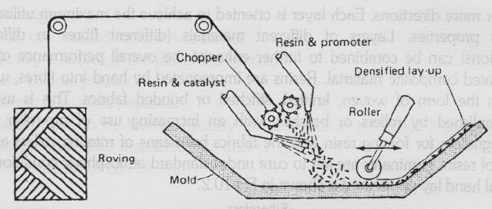

Fig 10.1

Advantages

- Widely used form any years.

- Low cost way of quickly depositing fibre and resin.
- Low cost tooling.

Disadvantages

- Laminates tend to be very resin-rich and, therefore, excessively heavy.

- Only short fibres are incorporated, which severely limits the mechanical properties of the laminate.

- Resins need to be low in viscosity to be sprayable. This generally compromises their mechanical/thermal properties.

- The high styrene content of spray lay-up resins generally means that they have the potential to be more harmful and their lower viscosity means that they have an increased tendency to penetrate clothing etc.

Applications

Simple enclosures, lightly loaded structural panels, e.g. caravan bodies, truck fairings, bathtubs, shower trays, some small dinghies.

9.1.2.1.1.2 Wet Lay-up/Hand Lay-up

The hand (wet) lay-up is one of the oldest and most commonly used methods for manufacture of composite parts. Hand lay-up composites are a case of continuous fibre reinforced composites. Layers of unidirectional or woven composites are combined to result in a material exhibiting desirable properties in one or more directions. Each layer is oriented to achieve the maximum utilisation of its properties. Layers of different materials (different fibres in different directions) can be combined to further enhance the overall performance of the laminated composite material. Resins are impregnated by hand into fibres, which are in the form of woven, knitted, stitched or bonded fabrics. This is usually accomplished by rollers or brushes, with an increasing use of nip-roller type impregnators for forcing resin into the fabrics by means of rotating rollers and a bath of resin. Laminates are left to cure under standard atmospheric conditions. A typical hand lay-up method is shown in Fig10.2.
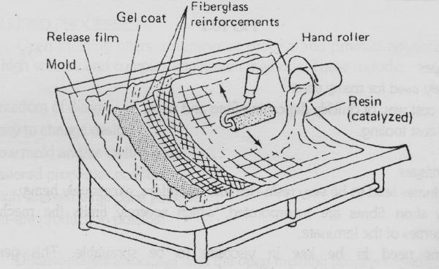

Fig 10.2

Some of the advantages and disadvantages of hand lay-up of composite structures are as follows:
Advantages

- Design flexibility.

- Large and complex items can be produced.
- Tooling cost is low.
- Design changes are easily effected.
- Sandwich constructions are possible.
- Semi-skilled workers are needed.
- Higher fibre content and longer fibres than with spray lay-up.

Disadvantages

- Only one molded surface is obtained.

- Quality is related to the skill of the operator.
- Low volume process.
- Longer cure times required.
- Resins need to be low in viscosity to be workable by hand. This generally compromises their mechanical/thermal properties.

- The waste factor can be high.

Applications

- Standard wind-turbine blades, production boats, architectural moldings.

9.1.2.1.1.3 Filament Winding

Filament winding is automated processes for creating parts of simple geometry wherein continuous resin impregnated fibres are wound over a rotating male tool called mandrel. Fig 10.3 depicts a filament winding process where a continuous fibre roving passes through a shuttle, which rotates and the roving is wrapped around a revolving or stationary mandrel. Two basic types of filament winding are in use - (i) the polar or planer method, and (ii) the high helical pattern winding.

The polar or planer method of winding utilizes a fixed mandrel and a shuttle that revolves around the longitudinal axis of the part to form longitudinal winding patterns. This type of winding is used if the longitudinal fibres are required with angle less than 25° to the mandrel axis. The polar winding schematic is shown in Fig 10.4.
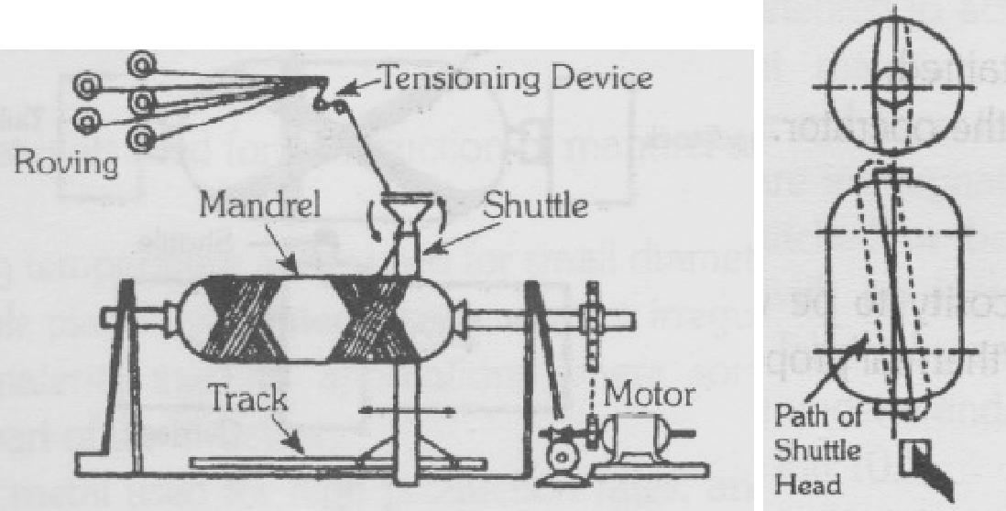

Fig10.3 Fig 10.4

In the high helical pattern winding, the mandrel rotates while the shuttle transverses back and forth. Both the mandrel rotation and shuttle movement are in the horizontal plane. By controlling the mandrel rotation and shuttle speed, the fibre angle can be controlled.

Angles of 25°-85° to the mandrel rotation axis are possible. The helical winding schematic is shown in Fig 10.5.
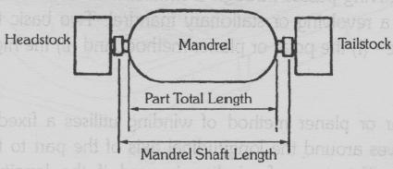

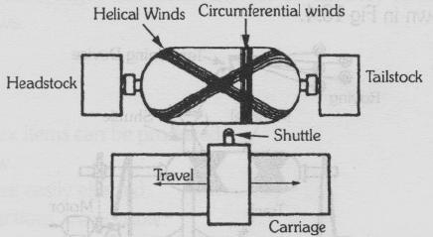

Fig 10.5

After completion of the winding, the filament wound structure is cured at room temperature or in an oven. The mandrel is removed after the curing. The mandrel, which determines accurate internal geometry for the component, is generally the only major tool. Low cost mandrel materials such as cardboard or wood can be used for winding low cost routine parts. For critical parts requiring close tolerances, expensive mandrels designed for long term use may be required. For high temperature cure 315°C (600°F), graphite mandrels with low thermal expansion may be advantageous. However, attention should be paid for potential difficulties for mandrel removal.

Mandrels are either removable or non-removable. Removable mandrels are classified according to the removal techniques as:

- Entirely removed.

- Collapsible.
- Breakable or soluble.

The selection of mandrel involves several considerations. These include part size and complexity, size of openings, resin system and its curing and the number of components to be fabricated. The requirements for a mandrel are:

- It must be stiff and strong enough to support its own weight and the weight of the applied composite while resisting the fibre tension pressure from winding and curing.
- It must be dimensionally stable and should have thermal coefficient of expansion greater than the transverse coefficient of the composite structure.

Different materials used for construction of mandrel are:

- Low melting temperature alloys used for small diameter applications.

- Sand, soluble plaster and eutectic salts used for irregular shapes.
- Inflatable material used in applications where sometimes the mandrel remains a part of the structure.

- Segmented metal used for high production rates, and where the mandrel can be withdrawn through a small hole in the part.

Of the above, segmented metal and inflatable mandrel are the reusable mandrels.

Advantages

- . Excellent mechanical properties due to use of continuous fibres.

- High degree of design flexibility due to controlled fibre orientation and lower cost of large number of composites.
- This is a very fast and economic method of laying down material.
- Resin content can be controlled by metering the resin onto each fibre tow through nips or dies.

Disadvantages

- Difficulty to wind complex shapes, which may require complex equipment.

- Poor external finish.
- The process is limited to convex shaped components.
- Fibre cannot easily be laid exactly along the length of a component.
- Mandrel costs for large components can be high.
- Low viscosity resins usually need to be used with lower mechanical properties.

9.1.2.1.1.4 Sheet Molding Compound

Sheet molding compound (SMC) refers to both a material and a process for producing glass fibre reinforced polyester resin items. The material is typically composed of a filled, thermosetting resin and a chopped or continuous strand reinforcement of glass fibre. A SMC processing machine, (Fig 10.6) produces molding compound in sheet form. The glass fibre is added to a resin mixture that is carried onto a plastic carrier film. After partial cure, the carrier films are removed. The sheet molding material is cut into lengths and placed onto matched metal dies under heat and pressure. Salient advantages of SMC molding process are as follows:

- High volume production.

- Excellent part reproducibility.
- Minimum material scrap.
- Excellent design flexibility.
- Parts consolidation.
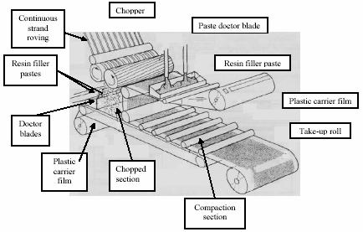

Fig 10.6

9.1.2.1.1.5 Expansion Tool Molding

Expansion tool molding makes use of rubber inserts in a metal or epoxy tool that expands when heated to provide the molding pressure. The advantage of expansion tool molding is its ability to fabricate parts without an autoclave. The method is dependent upon materials with high coefficients of thermal expansion. It is designed to utilize the difference in thermal expansion between rubber and the tooling material. The female areas of the mold are made of a material with a low coefficient of thermal expansion. The male plug is made of a silicon rubber or other rubber type tool material having comparatively high coefficient of thermal expansion. When the tool is heated, the rubber male plug expands at a much greater rate than the surrounding female tool.

Pressure up to 14 MPa (2000 psi) can be achieved at 175°C (350°F), which acts in all directions. The molding pressure can be controlled by controlling the temperature, rubber composition, rubber thickness and the ratio of rubber volume to the female mold volume.

Thermal expansion molding techniques are utilised for special applications of small complex composite structures and composite tubing with critical outside surfaces. Fig 10.7 illustrates the methods allowing the expansion of the silicone rubber to provide the required pressure for compacting of the composite materials.

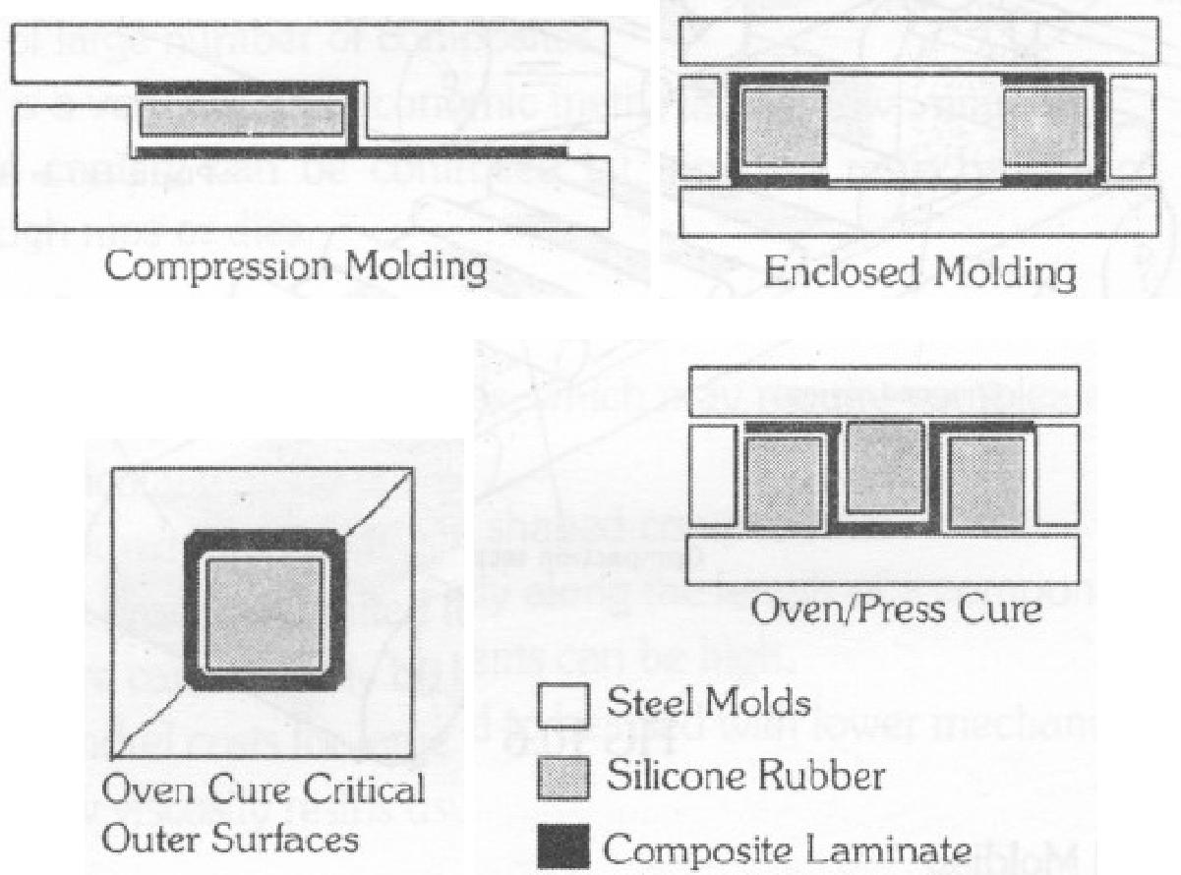

Fig 10.7

The linear thermal coefficient of most silicone rubbers fall in the range of 1-2.1x10⁵. This range is consistent over a 23-246°C (75-480°F) temperature range. The rubbers have a linear expansion of approximately17 times that of carbon steels due' to which they are used to mold composites by thermal expansion molding techniques. Silicone rubber is very slow to cool down and extra time must be allowed because the rubber is impossible to remove from the composite part until it has shrunk back to its original size..

9.1.2.1.1.6 Contact Molding

Contact molding involves the application of molding material to an open mold where it is allowed to cure. The process has been basically developed for the manufacture of large fibre glass components such as boats, automotive parts, etc. The process requires minimal tooling and equipment cost and thus is ideally suited for low volume production. The method has two basic approaches, namely hand lay-up and spray lay-up, which differ only in the manner in which. The material is applied to the mold. The method produces high quality surface finish on only one side of the final product.

Before the lay- up, the mold surface is coated with a thin layer of gel. After the lay-up, the part is allowed to cure at room temperature. The curing can be accelerated by using heat lamps.

The major advantages of the method are its simplicity and low cost. The disadvantages of the method are that only one good surface is produced while the other side is very rough. Secondly, the method is relatively slow due to long lay-up and cure time and thus it is not suitable for high volume production.

9.1.2.1.2 Closed Mold Processes

9.1.2.1.2.1 Compression Molding
Compression molding is one of the oldest manufacturing techniques in the composites industry. The recent development of high strength, fast cure, sheet molding compounds bulk molding compounds and advancement in press technology is making the compression molding process very popular for mass production of composite parts. Fully formed parts are molded in matched metal compression molds that give the final part shape. In comparison with the injection molding process, better physical and mechanical properties can be obtained in compression molding.

This process utilises large tonnage presses wherein the part is cured between two matched steel dies under pressure and high temperature. The moving platen is heated either by steam or electricity to promote thermal curing. Curing of the part is affected by the following factors:

- Size of platen, which determines the length and width of the part, which can be cured.
- Total tonnage of the press, which determines the pressure to be exerted on the projected surface area of the part.

After placing the laminate to be cured called the 'charge' in the core of the mold, the cavity is then closed at a rate of usually 4-12 mm/sec. In most cases the mold is heated to 150°C (302°F), which causes the charge viscosity to be reduced. With increasing mold pressure as the mold is closed, the charge flows towards the cavity extremities, forcing air out of the cavity. The molding pressure based on projected part area ranges from 0.7 to 9 MPa (100 to 1200 psi). Higher molding pressure causes sink marks, while lower pressure cause scumming of the mold and porosity. The curing time is usually between 25 sec to 3 minutes depending on several factors including' resin-initiator-inhibitor reactivity, part thickness, component complexity and mold temperature.

The exertion of high pressure eliminates the problem of development of voids. The primary advantage of the compression molding is its ability of producing large number of parts with little dimensional variations, if any, from part to part. A wide variety of shapes, sizes and complexity can be produced by compression molding. An important factor to be considered before deciding to use compression molding is the high tooling cost and the need for large heated presses. Thus, this method is not practical for low volume production.

Cure time is very critical. If the resin cure exotherm is not properly controlled, cracking, blistering or warping may occur. Fig 10.8 shows a typical compression mold.

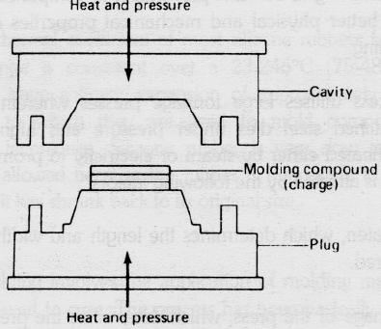

Fig 10.8
9.1.2.1.2.2 Vacuum Bag Molding
Today bag molded (vacuum and pressure) composites provide higher performance that results from optimisation of process controls, design refinements and improved materials.

Vacuum bagging techniques have been developed for fabricating a variety of aerospace components and structures. The process is principally suited to prepreg materials. This method utilises a flexible film or rubber bag that covers the part lay-up. The bag permits evacuation of the air to apply atmospheric pressure. The primary limitation of this method is the limited pressure that can be applie

The bag used in this method has two fold objectives:

- It provides a means for removing volatile products during cure; and

- It provides a means for the application of a pressure of one atom which is adequate for some materials.

The essential steps in the process are the lay-up, preparation of bleeder system and the

bagging operation. The required number of plies are cut to size and positioned in a mold.
When individual plies of a prepreg material are formed to the lay-up tool, certain amount
of voids exists between layers. The lay-up is covered with a flexible membrane or
vacuum bag, which is sealed around the edges of the mold by a sealant. An edge bleeder
is also placed near the edges of the lay-up. Its function is to absorb excess resin, which
may flow during curing.
Requirement for proper bagging are:

- Bag to be impervious to air pressure,

- Bag to uniformly apply the cure pressure,
- Bag not to leak under over-pressure, and

- Good and high capacity vacuum path to be provided to evacuate air from between the bag and the tool.

A vacuum is drawn on the lay -up, which helps in eliminating entrapped air. A maximum pressure of about 104 kPa (15 psi) is achieved in this method. The removal of excess resin results in higher fibre content and improved mechanical properties. The lay-up is usually allowed to cool at room temperature. To reduce the cure time, oven is preferred. A typical vacuum bag molding is shown in Fig 10.9.

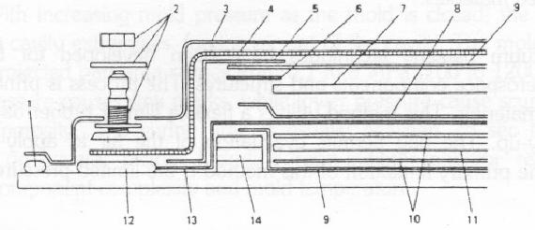

Fig 10.9

Functions of vacuum bag components are as follows:

No. | Component | Functions
1 | Bag sealant | Temporarily bonds vacuum bag to tool
2 | Vacuum fitting and hardware | Exhausts air, provides convenient connection to vacuum
 |  | pump
3 | Bagging film | Encloses part, allows for vacuum and pressure
4 | Open weave breather mat | Allows air or vacuum transfer to all of part
5 | Polyester tape (wide) | Holds other components of bag in place
6 | Polyester tape (narrow) | Holds components in place
7 | Caul sheet | Imparts desired contour and surface finish to composites
8 | Perforated release film | Allows flow of resin or air without adhesion
9 | Non-perforated release | Prevents adhesion of laminate film resin to tool surface
10 | Peel ply | Imparts a bondable surface to cured laminate
11 | Laminate
12 | Glass breather manifold | Allows transfer of air or vacuum.
13 | Glass bleeder ply | Soaks up excess resin
14 | Stacked silicon edge dam | Forces excess resin to flow vertically, increasing fluid
 |  | pressure

Two types of vacuum bags commonly used are - (1) expandable bagging, or (2) reusable bagging.

9.1.2.1.2.2.1 Expendable Vacuum Bagging

Bleed-out systems are devised to maintain reduced pressures within the bags contents. The bagged lay- up includes the bleed-out system designed for the composite part. Bagged lay-ups can be bled in two ways, namely vertically or edge bled. The basic difference between the two methods is shown in Fig 10.10 (a) & (b).
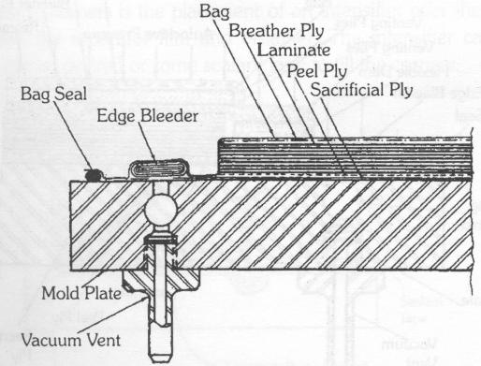

Fig 10.10(a)

Many of today's resin systems are mostly net resin and do not require any resin bleed during cure. This allows for better control of the resin content of the composite structures. If a resin bleed sequence is preferred, the following sequence can be used as a general guide:

- The surface of the mold is prepared with the release agent.

- The composite plies are applied and rubbed out to remove the entrapped air.
- A perforated release film is applied over the composite laminate and extended approximately 3.2mm beyond all edges.

- A predetermined number of bleeder plies are applied over the release film and extended to the perimeter of the lay-up.

- A perforated release film is applied over the bleeders and extended 3.2 mm from edge.

- One or two layers of a non-woven breather is placed over the lay-up and extended over the release film.
- Sealant tape is applied around the perimeter of the bleeder.
- The vacuum bag is positioned and sealed.
- The contents are evacuated and the bag is checked and sealed against leaks.
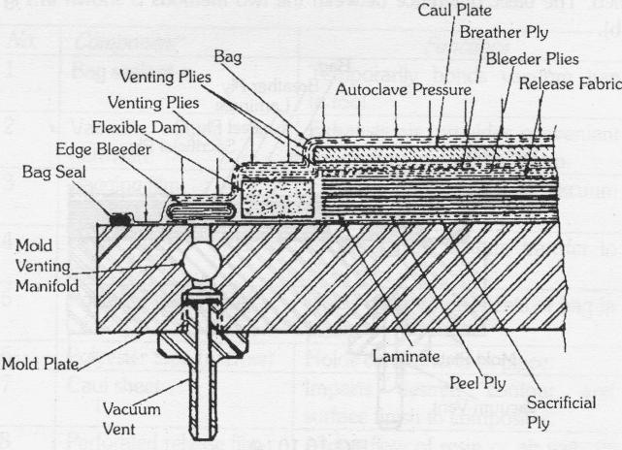
- The bagged lay-up is ready for curing.

Fig 10.10(b)

Vacuum bag bridging is one of the leading causes of resin rich and excessive voids in corners of composite laminates. Fig 10.11 illustrates this common problem.

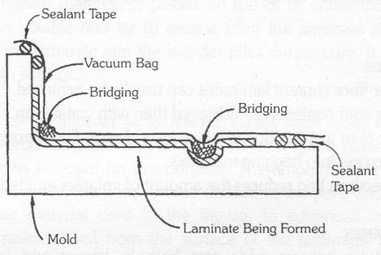

Fig 10.11
One method of eliminating bridging of the vacuum bag is presented in Fig 10.12 by means of 'ears' in the bag. Another method to help reduce resin rich and excessive voids in corners is the placement of an intensifier over the area, usually placed between the separator film and breather. The intensifier can be molded rubber in the radius desired or some sealant tape to fill the corners.

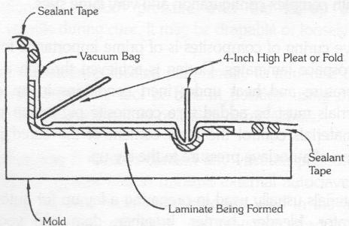
Fig 10.12

9.1.2.1.2.2.2 Reusable Vacuum Bagging

Due to material and recurring cost associated with the use of expendable vacuum bags, use of silicone rubber reusable bags are the solution.

Salient advantages and disadvantages of the vacuum bagging method are as follows:

Advantages

- Higher fibre content laminates can usually be achieved.

- Lower void contents are achieved than with wet lay-up.
- Better fibre wet-out due to pressure and resin flow throughout structural fibres, with excess into bagging materials.

- The vacuum bag reduces the amount of volatiles emitted during cure.

Disadvantages

- The extra process adds cost both in labour and in disposable bagging materials.

- A higher level of skills required by the operators.
- Mixing and control of resin contents till largely determined by operator skill.

9.1.2.1.2.3 Autoclave Molding

Autoclave molding is similar to vacuum bag process except that the lay- up is subjected to greater pressures and compact parts are produced. Primary disadvantage is high initial and recurring operating cost. The advantage is to produce parts with complex configuration and very large sizes.

Autoclave curing of composites is of prime importance for manufacturing high quality aerospace laminates. Curing is achieved through a combination of pressure, temperature and heat under inert conditions in an enclosed vessel. Processing materials must be added to a composite ply lay-up before autoclave curing. These materials control the resin content of the cured part and ensure proper application of autoclave pressure to the lay-up.

The materials usually used in preparing a lay -up for autoclave curing are peel ply, separator, bleeder, barrier, breather, dam and vacuum bag. The materials are compatible with the maximum cure temperature and pressures required for the matrix system being cured. The peel ply if used is placed immediately on top of or under the composite laminate. It is ultimately removed just before bonding or painting operations so that a clean, bondable surface is available.

A separator (release material) is placed on top of or under the laminate and peel ply. It

allows volatile and air to escape from the laminate and excess resin to be bled from the
laminate into the bleeder plies during cure. It also gives the cured part a smooth surface.

The purpose of the bleeder is to absorb excess resin from the lay-up during cure, thereby producing the desired fibre volume. Fibre glass fabric or other absorbent materials are used for this purpose. The amount of bleeder used is a function of its absorbency, the fibre volume desired in the part, and the resin content of the prepreg material used in the lay-up. In advanced composites essentially all excess resin is bled from the surface of the laminate, with edge bleeding being minimised by properly damming the lay-up edges.

The barrier is commonly placed between the bleeder plies, and breather plies. In the case of epoxy resin, unperforated film is used so that resin removal from the part can be controlled. For resins that produce volatile by-products during cure, a film with small perforations and large spacing is used to prevent the breather materials from becoming clogged with resin.

The breather is a material placed on top of the barrier film to allow uniform application of vacuum pressure over the lay-up and removal of entrapped air or volatile during cure. It may be drapable or loosely woven fabric.

The dam is sometimes located peripherally to minimise edge bleeding. It maybe an integral part of the tool or built-in position using materials such as pressure-sensitive tape, silicone rubber or Teflon or metal bars.

The vacuum bag is used to contain any vacuum pressure applied to the lay-up before and during cure and to transmit external autoclave pressure to the part. It prevents any gaseous pressurizing medium used in the autoclave (air or inert gas) from permeating the part and causing porosity and poor or unacceptable part quality.

Major components of autoclave are - a vessel to contain pressure; sources to heat the gas stream and circulate it uniformly within the vessel; a sub-system to pressurize the gas stream; a sub-system to apply vacuum to parts covered by a vacuum bag; a sub-system to control operating parameters; and a sub-system to load the models into the autoclaves.

The materials, which can be processed in the autoclave, are metal bonding adhesives, reinforced epoxy laminates, thermoplastic laminates, ceramics, carbon matrix materials; and many other applications.

An autoclave system allows a complex chemical reaction to occur inside a pressure vessel according to a specified schedule in order to process a variety of materials. The pressure and temperature requirements are governed by the type of material to be cured. The evolution of materials and processes has taken autoclave operating conditions from 120°C (248°F) and 276 kPa (40 psi) pressure to well over 760°C (1400°F) and 69 MPa (10000 psi). Epoxy matrix composites, in general, use autoclave cure cycles, which involve487-690 kPa (85 -100 psi) pressure and 175°C (350°F) temperature. The materials processed in autoclaves range from metal bonding adhesives, reinforced epoxy laminates, thermoplastic laminates, metal, ceramic and carbon matrix materials, to many other aerospace and electronic components. Autoclave is generally provided with automatic programmable controllers, which monitor and maintain the required heat up and cool down cycles. The vacuum surrounding the part lay-up is also controlled and is discontinued after initial temperature increase to prevent excess resin flow. Brief functioning of various parts of autoclave is discussed in the following paras.

Gas Stream Heating

Several heating methods are available for autoclave systems. Most common method for large autoclaves is indirect gas firing in which products of combustion are passed from external chamber to an internal coil. Gas heating is regularly used in autoclaves with maximum operating temperature of 450°-540°C (8500-1000°F).

Earlier, hot oil was used as a heating medium in which oil was circulated from an external heater to an internal coil. This system became obsolete due to contamination problems of bonding area leading to improper processing of parts. Steam heating is often used for autoclaves operating in the 150°-175°C (3000-350°F) range. The superheated steam is passed through a coil in the autoclave to heat the circulating gas. Most small autoclaves are electrically heated.

Gas circulation, within the autoclave, is essential to provide temperature uniformity and proper heat transfer to the loaded part. The gas circulation is maintained at 1 to 3 m/s (250to 300 ft/min) in the workspace.

Gas Stream Pressurisation

The three pressurizing gases typically used for autoclaves are (a) air (b) nitrogen and (c) carbon dioxide.

Air is used for most of the 120°C (250°F) cures. However, disadvantage of air is that it sustains combustion and maybe hazardous at temperatures above 150°C (300°F). Nitrogen is commonly used in the autoclaves. Liquid Nitrogen is stored in cryogenic form and then vaporised at approximately 1380 to 1552 kPa (200 to 225 psi). Carbon dioxide is the second most commonly used gas. It is stored as refrigerated liquid at approximately 2070 kPa (300 psi). Disadvantages of carbon dioxide are its high density, hazards to personnel, etc.

Vacuum Systems

Most parts processed in autoclaves are covered with vacuum bags, which are used primarily for compaction of laminates and to provide vacuum for removal of volatile products. The bag allows the part to be subjected to differential pressure in the autoclave without being directly exposed to the autoclave atmosphere. The vacuum bag is also used to apply varying levels of vacuum to the part. The ability to provide pressure on the part under the bag by means of vacuum results in reduced void content.

Control System

The injection molding process generally has the following advantages over the compression molding:

- More readily automated process,

- Permits finer part detail.

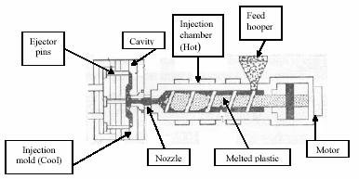

Control system means ability to monitor and control cure cycles. The cure cycle is controlled by feedback from thermocouples, transducers and sensors, which are provided at different locations in the autoclave.

Loading System

Carts or trolleys help in placing the parts horizontally and vertically in the autoclave. The parts are loaded s~ that they are accessible to enable repair of bag leaks. All vacuum sources and vacuum sensor lines are connected to the part when loaded on cart and desired vacuum maintained. The cart must be gently rolled into the autoclave.

At present, computer controlled autoclaves with facility for storage of up to 60 different curing cycles programmes are available in the world market.

In industry, autoclave curing of composites is used to improve cured product quality and reduce fabrication costs by providing:

- Process optimization.

- Reduced process inconsistencies and product rejections. Accurate, real-time quality assurance with rapid error detection and correction.

- Verification of process reaction behaviour kinetics.
- Non-destructive verification of cured properties.
- Accurate, permanent process documentation.
- Flexibility in adapting to new or modified processes.

9.1.2.1.2.4 Injection Molding

Injection molding refers to a process that generally involves forcing or injecting a fluid plastic material into a closed mold. It is differentiated from compression molding, in which plastic materials in a soft but not fluid condition are formed by transferring them into an open mold, which is then forcibly closed. This method is not normally used in polymeric matrix compound processes due to fibre damage in the barrel.

The molding compound is fed into injection chamber through the feed hopper. The molding compound is heated in the injection chamber wherein it changes into liquid form. It is forced into the injection mold by the plunger. A typical injection mold is shown in Fig 10.13.
The injection molding process generally has the following advantages over the compression molding:

- More readily automated process,

- Permits finer part detail.

Fig 10.13

The part and the mold can often be designed in a manner so that no subsequent trimming or machining operations are required. However, all plastic materials cannot be injection molded successfully. There are two basic categories of plastic injection molding (a) thermoplastic and (b) thermoset. In the former, a thermoplastic material is melted and forced through an orifice into the mold, which is kept relatively cool. The material solidifies in the mold from which it can then be removed. In thermoset injection molding, the solidification occurs at high temperature. Therefore, a reaction material is forced into a generally warm mold in which the material further polymerises into a solid part.

This method is normally used for high- volume and low-cost component manufacturing. The disadvantage of the method is that it is limited to materials with very short fibre lengths. Also, since there is large amount of flow during the process, material non-uniformities do exist.

9.1.2.1.2.5 Resin Transfer Molding (RTM)

Resin transfer molding is a closed mold low pressure process that allows the fabrication of composites ranging in complexity from simple, low performance to complex, high performance parts and in size from small to large (Fig10.14). The process is differentiated from other molding processes in that the dry reinforcement and the resin are combined within the mold to form the composite component. The fibre reinforcement, which may be pre-shaped, is placed into a tool cavity, which is then closed. A tube connects the closed tool cavity with a supply of liquid resin, which is pumped or transferred into the tool to impregnate the reinforcement for subsequent curing. Injection pressure is normally less than 690 kPa (100 psi) . The displaced air is allowed to escape through vents to avoid dry spots. Cure cycle is dependent on part thickness, type of resin system and the temperature of the mold and resin system. The part cures in the mold, normally heated by controllers.
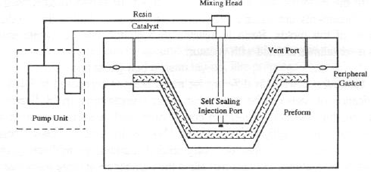

Fig10.14
The advantages and associated disadvantages of the RTM process are given below:

Advantages

- Parts can be made with better reproducibility than with wet lay-up.

- Reinforcement and combination of reinforcements can be used to meet specific properties.
- Production cycles are much faster than with wet lay-up.
- Using matched tools for the mold, one can improve the finish of all the surfaces.
- Mechanical properties of molded parts are comparable to other composite fabrication processes.

- Large and complex shapes can be made efficiently.
- Volatile emissions are low because RTM is a closed mold process.
- The skill level of operator is less critical.
- Mold surfaces can be gel coated to improve surface performance.

Disadvantages

- The mold design is critical and requires good tools or great skill.

- Reinforcement movement during resin injection is sometimes a problem.
- Control of flow pattern or resin uniformity is difficult. Radii and edges tend to be resin rich.

Vacuum Assisted Resin Transfer Molding (VARTM)

In the RTM process, a matched set of molds or closed mold is used. The fibre reinforcements are usually pre-shaped off line to enhance the production cycle time of the molds. Resin is injected through the injection ports and the process is sometimes assisted with vacuum.

However, VARTM is different for many reasons compared to RTM. First, the fabrication of parts can be accomplished on a single open mold. Second, the process uses the injection of resin in combination with a vacuum and captured under a bag to thoroughly impregnate the fibre reinforcement. This process has been used to make both thin and very thick laminates. In addition, complex shapes with unique fibre architectures allow the fabrication of large parts that have a high structural performance.

Fabrics are laid up as a dry stack of materials as in RTM and covered with peel ply and a knitted type of non-structural fabric. The whole dry stack is then vacuum bagged, and once bag leaks have been eliminated, resin is allowed to flow into the laminate. The resin distribution over the whole laminate is aided by resin flowing easily through the non structural fabric, and wetting the fabric.

Advantages

- Much lower tooling cost due to one half of the tool being a vacuum bag.

- Large components can be fabricated.
- Standard wet lay-up tools may be modified for this process.
- Cored structures can be produce din one operation.

Disadvantages

- Relatively complex process to perform well.

- Resins must be very low in viscosity, properties, thus compromising mechanical
- Unimpregnated areas can occur resulting in very expensive scrap parts.

Resin Film Infusion (RFI)

In resin film infusion process, dry fabrics are laid up interleaved with layers of semi-solid resin film supplied on a release paper. The lay-up is vacuum bagged to remove air through the dry fabrics, and then heated to allow the resin to first melt and flow into the
air-free fabrics, and then after a certain time, to cure. The main attraction of resin film infusion is probably for parts of high surface area.

Advantages

- High fibre volumes can be accurately achieved with low void contents.

- Good health and safety and a clean lay-up, like prepreg.
- High resin mechanical properties due to solid state of initial polymer material and elevated temperature cure.

Disadvantages

- Not widely proven outside the aerospace industry.

- Tooling needs to be able to withstand the process temperatures of the resin film.
- Core materials need to withstand the process temperatures and pressures.

9.1.2.1.3. Continuous Processes

9.1.2.1.3.1 Pultrusion
Pultrusion is an automated process used to create shapes by pulling rovings through a shaped and heated die. The use of pultruded parts in aircraft is limited to specialized applications. Practical applications are limited to constant cross-section parts. Pultrusion is used to manufacture constant cross-section shapes, viz., I-beam, box, channels, tubings, etc.

The Pultrusion process machine consists of six different parts namely, the creel, the resin bath, the forming die, the heated curing die, the pullers and the cut -off saw. The creel is the beginning of the Pultrusion process and is the material storage system from which the fibres and mat or fabric are drawn in the correct sequence to match the design requirements of the structural shape. Virtually all Pultrusion processes utilise a resin impregnation bath to facilitate the impregnation of the resin into the fibre structure. The use of pre-impregnated fibres eliminates the resin bath.

Two types of dies are used in Pultrusion process, namely, the forming and the heating or curing die. Forming is done immediately after the impregnation process. Forming dies are normally attached to the heating or curing die in order to provide the correct relationship between the forming and the heated curing step. The rovings go through a heated die that represents the cross-section of finished part. Curing is accomplished by heating the die. The product continuously pulled out and as it comes out of the puller mechanism, it is cu the desired length by an automatic saw.

The process is continuous and can be used to manufacture extremely long sections. At typical continuous Pultrusion process is shown in Fig10.15.

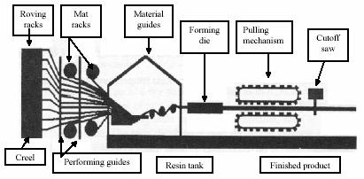
are used to make fishing rods and electrical insulator rods which require high axial tensile strength. The second category consists of structural profiles, which uses a combination of axial fibres and multi-directional fibre mats to create a set of properties that meet the requirements of the application in the transverse and longitudinal directions.

More than 90% of all pultruded products are fibre glass reinforced polyester. When better corrosion resistance is required, vinyl ester resins are used. When a combination of superior mechanical and electrical properties is required, epoxy resin is used. Higher temperature resistance and superior mechanical properties generally dictate the use of epoxy resins reinforced with aramid or carbon fibres.

The major limitation of this method for aircraft use is the constant cross section requirement. Also, more complex geometries are not feasible by this technique. The chief advantage of the method is the ability to produce consistent parts at very low cost in a short period of time. Pultruded composite parts exhibit all the features produced by other composite processes, such as, high strength to weight ratio, corrosion resistance, dimensional stability, etc.

Advantages

- Production is continuous.

- Material scrap rate is low.
- The requirement for support material is eliminated i.e., breathers. bleeder, cloth, separator film, bagging film, edge tape, etc.

- Labour requirements are low.

Disadvantages

- Limited to constant or near constant cross-section components.

- Heated die costs can be high.

9.1.2.1.3.2 Braiding

The braiding process involves the weaving of fibres into shape by repeatedly crossing them back and forth over a mandrel. The use of braiding process in the aircraft industry is generally restricted to non- structural applications. The braiding process has been utilised extensively for covering of the electrical wires and fuel lines. The primary advantage that

braiding offers is a rapid, automated method for forming an interwoven structure. The method is a product of textile technology and usually utilises equipment adapted from the textile industry. The braiding carriers follow a zigzag path in a large circle surrounding the mandrel. The surface of the mandrel is tightly woven with the fibres in a helical pattern.

Due to high level of conformability and the damage resistance capability of braided structures, the composite industry had found structural applications of braided composites ranging from rocket launchers to automotive parts to aircraft structures.

2- D braided structures are inter-twined fibrous structures capable of forming structures with 0° and ±θ fibre orientation. Although 2 -D braids can be fabricated in tape form, the majority of braided structures are fabricated with tubular geometry. Thickness is built up by over braiding previously braided layers similar to a ply lay-up process. Braiding can take place vertically or horizontally. A schematic of a horizontal braider is shown in Fig 10.16. Although braiding is similar to filament winding, the major difference between braiding and filament winding is that braids are interlaced structures having as many as 144 or more interlacing per braiding cycle.
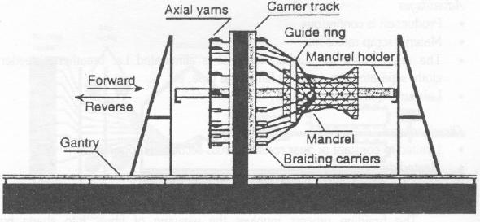

Fig 10.16

There are two categories of Pultrusion products. The first category consist of solid rod and bar stock produced from axial fibre glass reinforcements and polyester resins. These

3-D braiding technology is an extension of 2-D braiding in which the fabric is constructed by the inter-twining or orthogonal interlacing of yarns to form an integral structure through position displacement. A unique feature of 3-D braids is their ability to provide through the thickness reinforcement of composites as well as their ready adaptability to the fabrication of a wide range of complex shapes ranging from solid rods to I-beams to thick walled rocket nozzles. A generalized schematic of a 3-D braiding process is shown in Fig10.17.

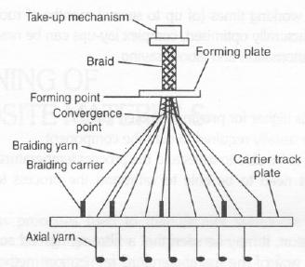

Fig 10.17

*Prepreg Molding

In prepreg molding, fabrics and fibres are pre-impregnated under heat and pressure or with solvent, or a pre-catalysed resin. The catalyst is largely latent at ambient temperatures giving the material useful life when defrosted. The resin is usually a near solid at ambient temperatures, and so the pre-impregnated materials (prepregs) have a light sticky feel, such as that of adhesive tape. The prepregs are laid up by hand or machine onto a mold surface, vacuum bagged and then heated to typically120-180°C

(248-356°F). This allows the resin to flow followed by curing. Additional pressure for the molding is usually provided in an autoclave.

Advantages

- Resin/catalyst levels and the resin content in the fibre are accurately set by the materials manufacturer. High fibre contents can be safely achieved.
- The materials have excellent health and safety characteristics and are clean to work with.

- Fibre cost is minimised in unidirectional tapes since there is no secondary process to convert fibre into fabric prior to use.
- Resin chemistry can be optimised for mechanical and thermal performance, with the high viscosity resins being impregnable due to the manufacturing process.

- The extended working times (of up to several months at room temperatures) means that structurally optimised, complex lay-up scan be readily made.

- Potential for automation and labour saving. .

Disadvantages

- Materials cost is higher for pre-impregnated fabrics.

- Autoclaves are usually required to cure the component.
- Tooling needs to be able to withstand the process temperatures involved.
- Core materials need to be able to withstand the process temperatures and pressures.

In conclusion, it may be seen that a fibre reinforced composite may be manufactured by one of the many standard fabrication methods as explained above. The selection of the best method for a given application requires the consideration of numerous factors. The selection process must determine the appropriate constituent materials, the actual part design, the required tooling, the fabrication process and the necessary inspection and testing requirements to assure part quality.

